**Unit 2: Atomic Structure and Bonding** 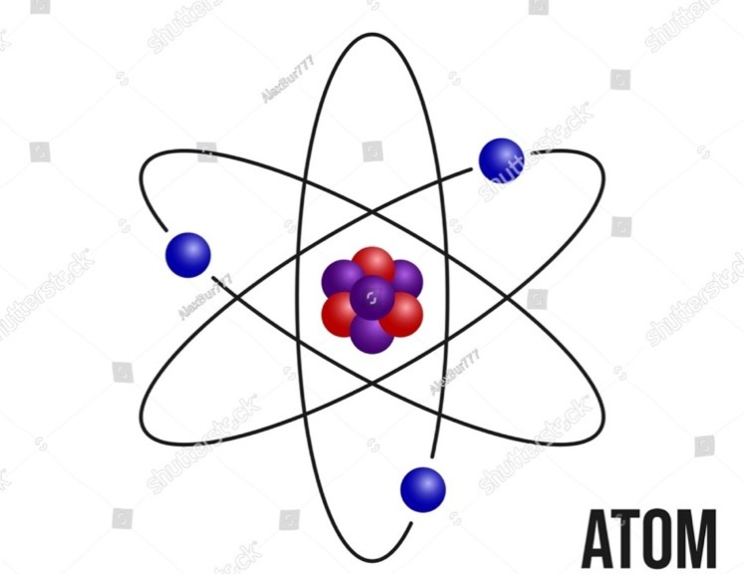

**Chapter 6: Ionic and Metallic Bonding**

**Lesson 2 Ionic Bonding and Compound Formation**

**~~Reading Guide:~~** ~~As you read the lesson, complete the chart.~~

~~Add section titles to the first column.~~

~~Add details that explain the main ideas of each section in the second column.~~

**Key Vocabulary**

* **Ionic bond:** a type of chemical bond formed by the electrostatic attraction between a cation and an anion.
* **Lattice energy:** the energy released when an ionic compound is formed from its constituents’ ions in gaseous state.

**Vocabulary Check:**

Which vocabulary words are you familiar with?

* Add a check mark by the word(s) that you know.
* Add a star to note which word(s) you will need to study.

**Lesson Summary:**

In this lesson, you explored ionic bonding, which takes place between a cation and an anion by the transfer of an electron such as in sodium chloride (NaCl). Ionic compounds form different crystalline structures that have different properties, such as solubility in water.

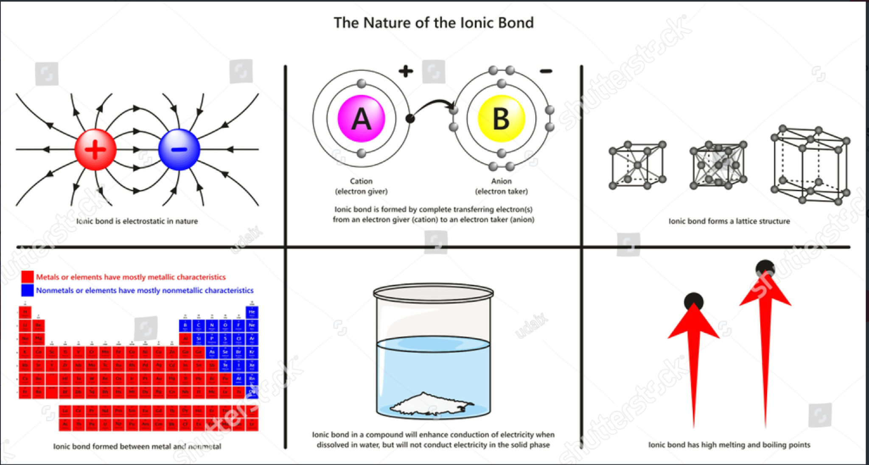

Shutterstock Illustration ID: 1088542712 Art direction: remove the periodic table and the red arrows, so that this is ONLY a four cell infographic.

**:**

**Lesson Summary:**

(Hint: Use the Infographic and your text to discover the answers to these questions)

* What happens when atoms or molecules gain or lose electrons?
* What is the octet rule?
* What is the difference between lattice energy and hydration energy?

**Hands on Demonstration: Formation of Ionic Compounds**

|  |  |
| --- | --- |
| **Procedure** | **Materials:**   * NaCl solution (0.1 M) * AgNO3 solution (0.1 M) * Test Tubes * Pipettes * Beakers * Stirring Rod   **Procedure:**   * Pour 10 mL of NaCl solution into a test tube. * Use a pipette to add AgNO₃ solution drop by drop to the test tube. * Observe what happens and record your observations in your lab notes. |
| **Conduct the demonstration and collect data**     |  |  | | --- | --- | |  |  | | *Record your observations in the table below. You may also draw what you see.*   |  | | --- | | **Observations /** **Notes** | |  | |
| **Analysis of Data**  **Drawing Conclusions** | * Look for patterns and cause-and-effect relationships:     __________________________________________________________________________________________________________________________   * Compare initial and final observations of the materials and solutions.     __________________________________________________________________________________________________________________________   * Reflect on the possible nature of the white precipitate based on the ions present in the solution.   __________________________________________________________________________________________________________________________   * Why do you think the white precipitate formed? Discuss with classmates.   __________________________________________________________________________________________________________________________   * Draw conclusions.     __________________________________________________________________________________________________________________________ |
| **Further Research Questions** | With your group:   * Elaborate other investigative questions that could further advance research about ionic crystals     __________________________________________________________________________________________________________________________ |

**Progress Check**

1. Identify which pairs of atoms are most likely to form an ionic bond. Explain your choices.

|  |  |  |
| --- | --- | --- |
| Pairs of atoms | Form ionic bond? (yes or no) | Explain |
| Sodium (Na) and Fluorine (F) |  |  |
| Oxygen (O) and Hydrogen (H) |  |  |
| Magnesium (Mg) and Chlorine (F) |  |  |
| Carbon (C) and Nitrogen (N) |  |  |
| Potassium (K) and Sulfur (S) |  |  |
| Neon (Ne) and Argon (Ar) |  |  |
| Calcium (Ca) and Oxygen (O) |  |  |
| Cooper (Cu) and Cooper (Cu) |  |  |

1. Consider the compound rubidium iodide (RbI).

**Part 1:** Explain the bonding of this compound, including details about

* the sizes of the atoms,
* the ions formed,
* and the structure of the compound.

**Part 2:** Create a diagram showing the ionic bonding and structure in RbI.

**Part 3:** What properties would you expect RbI to have?

1. Cinnabar (HgS) has an attractive vermilion color and has been used as a pigment since ancient times. It needs to be mixed with oil because it does not dissolve in water. In contrast, KCl, used in agriculture and medicine, does dissolve in water. Explain why these compounds present differences in water solubility.
2. Suppose a scientist measured the lattice energy of two different compounds.

**Part 1:** The lattice energy of Compound A measured 3874 kJ/mol and the lattice energy of Compound B measured 795 kJ/ mol.

**Part 2:** Explain why there is such a big difference in the lattice energy of these compounds. ~~(Answer: because the magnitude of the potential of the ions of Compound A is greater than the magnitude of the potential of the ions of Compound B)~~

1. Consider the compound calcium fluoride (CaF2).

**Part 1:** Explain the bonding of this compound, including details about

* the sizes of the atoms,
* the ions formed,
* and the structure of the compound.

**Part 2:** Create a diagram showing the ionic bonding and structure in CaF2.

1. **ACT Practice Question:**

When writing the formula for an ionic compound, there are several rules. The name of the metal is written first, and the name of the nonmetal is written second. An ending is added to the name of the nonmetal; the name always ends in -IDE. If the element can have many possible charges, a roman numeral is added to the name. For example, Nickel (II) represents that in an example compound, Nickel has a charge of +2.

Mercury (II) (Hg) has a charge of +2. Oxygen (O) has a charge of -2.

Which of the following is the correct chemical compound name and formula?

1. Mercury Oxide, HgO CORRECT
2. Mercury Oxygen, HgO
3. Mercury (II) Oxide, Hg2O
4. Mercury Oxygen, Hg2O

Explanation: Mercury (II) releases 2 electrons and Oxygen gains 2 elections. This is minus 2 and plus 2, so the charges added together are zero. This gives us the formula: HgO.

Mercury is one of the elements that has many different possible charges.

The roman numeral II means 2. If we write Mercury (II), it means Mercury with a charge of +2.

So, we spell out the formula as Mercury (II) Oxide.

Or we could do something like this instead:

[**https://www.varsitytutors.com/act_science-help/act-science?page=87**](https://www.varsitytutors.com/act_science-help/act-science?page=87)